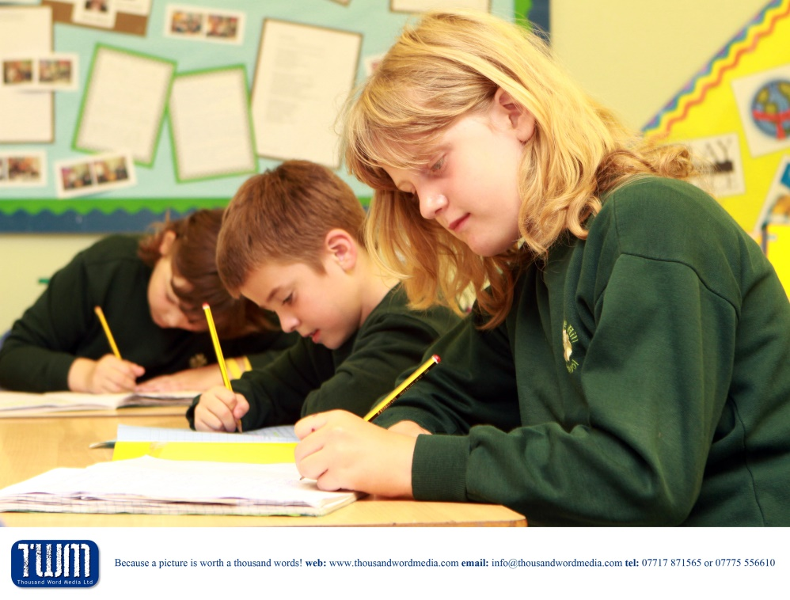

Class Teacher (Small Groups)

Hardwicke Parochial Primary School

Dear Applicant,

The closing date for completed applications is 1st December 2023.

Interviews are scheduled to take place on the week beginning 18th December 2023.

To submit your application please email the completed form to [admin@hardwicke.gloucs.sch.uk](mailto:admin@hardwicke.gloucs.sch.uk) before the closing date.

Yours faithfully.

Miss Sharon Cale

The Diocese of Gloucester Academies Trust seek to appoint a

**Class Teacher (Small class of pupils)**

This is a full or part-time position. (Fixed Term)

We are looking for an enthusiastic teacher to join our hardworking and talented team. The Class Teacher will be responsible for the delivery of the National Curriculum to a small group of pupils with additional needs. The curriculum will be bespoke and will be delivered with the support of an experienced teaching assistant and guidance from the SENDCo.

We would like to work with the successful candidates to adapt the post to suit their needs and the schools, therefore the role could be either full or part-time.

We have high expectations of our staff and children and need an ambitious teacher who will live out our vision and values.

**We are looking for a candidate who**

* will be patient and understanding of the individual needs of pupils
* will be able to motivate and engage with pupils
* is a team player and is able to work closely with parents and the SENDCo

**We can offer you**

* Support and excellent professional development
* A dedicated and friendly team
* Enthusiastic, motivated and happy children

Further details and an application form can be downloaded from the vacancy area of our website.

If you would like an informal conversation about the role please contact Miss Sharon Cale on 01452 720538 or email [admin@hardwicke.gloucs.sch.uk](mailto:admin@hardwicke.gloucs.sch.uk)

The Diocese of Gloucester Academies Trust is committed to safeguarding and promoting the welfare of children and young people and expects all staff to share this commitment. An enhanced DBS check is required for the successful candidate and social media checks are completed at the shortlisting stage as per guidance from KCSIE 2022.

Candidates should refer to our school website for our approaches to safeguarding and child protection:

Our Child Protection and Safeguarding Policy

Staff Code of Conduct:

Safer Recruitment Policy including appointment of ex-offenders

**Job Description**

**Job Title:** Class Teacher

**Responsible to:** Miss Sharon Cale

**Line Management:** Mrs Jen Panton

**Contract Type:** Full-time or Part-time – fixed term

The responsibilities of the post are to be performed in accordance with the provisions of the most up-to-date edition of the School’s Teachers’ Pay and Conditions document and within the range of teachers’ duties set out in that document.

**Main Purpose:**

**The teacher will:**

• Fulfil the professional responsibilities of a teacher, as set out in the School Teachers’ Pay and

Conditions Document

• Meet the expectations set out in the Teachers’ Standards

**Duties and Responsibilities:**

**Teaching:**

• Plan and teach well-structured lessons to assigned classes, following the school’s plans, curriculum

and schemes of work

• Assess, monitor, record and report on the learning needs, progress and achievements of pupils,

making accurate and productive use of assessment

• Adapt teaching to respond to the strengths and next steps of pupils' learning

• Set high expectations which inspire, motivate and challenge pupils

• Promote good progress and outcomes by pupils

• Demonstrate good subject and curriculum knowledge

**Whole-school organisation, strategy and development**

• Contribute to the development, implementation and evaluation of the school’s policies, practices and procedures, so as to support the school’s values and vision

• Make a positive contribution to the wider life and ethos of the school, including the faith community and DGAT

• Work with others, including DGAT colleagues, on curriculum and pupil development to secure co-ordinated outcomes

• Provide cover, in the unforeseen circumstance that another teacher is unable to teach

**Health, safety and discipline**

• Promote the safety and wellbeing of pupils

• Follow school procedures with regard to identifying and responding to safeguarding concerns

• Maintain good order and discipline among pupils, managing behaviour effectively to ensure a good and safe learning environment

**Professional development**

• Take part in the school’s appraisal procedures

• Take part in further training and development in order to improve your own teaching and understanding of the Christian faith

• Where appropriate, take part in the appraisal and professional development of others

**Communication**

* Communicate effectively with the board of governors and board of trustees
* Communicate effectively with pupils, parents and carers

**Working with colleagues and other relevant professionals**

• Collaborate and work with colleagues and other relevant professionals within and beyond the

school, including DGAT colleagues

• Develop effective professional relationships with colleagues

**Personal and professional conduct**

• Uphold public trust in the profession and maintain high standards of ethics and

behaviour, within and outside the school

• Have proper and professional regard for the faith, ethos, policies and practices of the school, and

maintain high standards of attendance and punctuality

• Understand and act within the statutory frameworks setting out their professional duties and

responsibilities

**Management of staff and resources (where appropriate**)

• Direct and supervise support staff assigned to them, and where appropriate, other teachers

• Contribute to the recruitment and professional development of other teachers and support staff

• Deploy resources delegated to them

The teacher will be required to safeguard and promote the welfare of children and young people and follow school policies and the staff code of conduct. Please note that this is illustrative of the general nature and level of responsibility of the role. It is not a comprehensive list of all tasks that the teacher will carry out. The post holder may be required to do other duties appropriate to the level of the role, as directed by the headteacher or line manager.