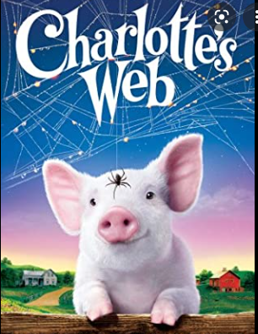
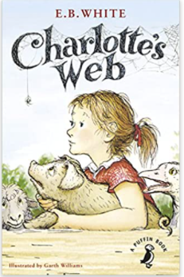
18.02.22 3H Guided Reading
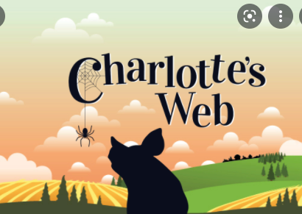

Design your own book cover for Charlotte’s Web. Think about the different characters in the story and how to incorporate them on the cover. Write a short blurb to explain the outline of the story.

