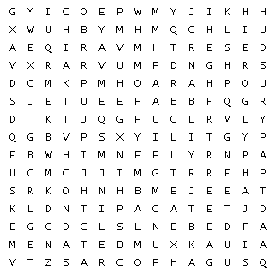
18.2.22 WALT find keywords relevant to Ancient Egypt.
Africa |  | afterlife |  | deben
desert |  | Egypt |  | embalm
hieroglyph |  | lyre |  | market
menat |  | mummy |  | Nile
papyrus |  | pharaoh |  | pyramid
sarcophagus |  | scribe |  | sickle
sphinx |  | tomb

