DATE: Friday 18th February 2022
WALT: review, consolidate and improve our reading skills
- WILF: Explain how authors capture a reader’s imagination
Now we have completed “Moondial”, write a short description of the book, explaining:
- what type of story it is
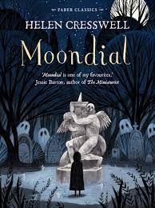
- which characters you liked/disliked
- whether you would recommend it to a friend – and why.

