At Hardwicke Parochial Academy, We Love Reading:
Subject Intent:
Our aim is to improve pupils' future prospects by ensuring that every child becomes a fluent, enthusiastic reader. We are committed to helping our pupils speak, read, and write fluently; equipping them with the skills they need to flourish in later life. We are determined to ensure that our pupils can speak read and write fluently so they can succeed in future life.

Together we love, learn and live…
At Hardwicke we aim…
·To ensure children’s phonic skills are secure as early as possible, as these are essential to developing as a competent, assertive reader.
·To provide early reading foundations that enable pupils to be enthusiastic readers with a passion and love for storytelling, literature and vocabulary.
·To ensure that all children learn to read and read to learn.
· For children to become enthusiastic and motivated readers
·To immerse children in a range of genres, in order to develop cultural capital and provoke thought (Windows and mirrors)
·To encourage a love of literature and enjoyment of reading
· Through thorough tracking, we ensure that no child is left behind; those few pupils who find learning to read a challenge are supported through rigorous interventions to cater for their needs.

Implementation:
Early Years Foundation Stage (EYFS)
In EYFS, the focus is on building early reading skills through daily ELS phonics sessions, whilst providing regular opportunities for children to listen to stories, and develop a love of reading from the start of their educational journey. Guided reading sessions are conducted daily, using decodable books that align with the school’s systematic synthetic phonics program. These sessions focus on developing early comprehension by encouraging children to discuss illustrations, predict storylines, and retell familiar stories, helping to expand their oral vocabulary and understanding. Reading fluency is supported through repeated practice with phoneme-grapheme correspondences and participation in rhymes and rhythm-based activities, which enhance expression.
Key Stage 1 (KS1)
In KS1, guided reading focuses on advancing children’s decoding skills, comprehension, and ability to engage with texts critically. Daily reading sessions involve teacher-led discussions and activities that explore vocabulary, inference, prediction, and explanation using carefully selected books that challenge and engage the children. VIPERS strategies (Vocabulary, Inference, Prediction, Explanation, Retrieval, and Sequencing) are used to develop comprehension skills and support analytical thinking. Reading fluency is promoted through activities such as choral and echo reading, teacher-modelled expressive reading, and regular practice with short passages to develop accuracy, pace, and expression. Termly fluency assessments track children’s progress in these areas.
Key Stage 2 (KS2)
In KS2, guided reading sessions focus on strengthening comprehension, critical thinking, and an appreciation for diverse texts. These sessions use a variety of texts, and include activities like summarising, annotating, and discussing themes and ideas in depth. Texts are chosen to progressively challenge and engage readers, building their confidence in tackling complex material. Reading fluency is further developed through paired reading and echo reading, with a focus on expression, intonation, and phrasing when reading aloud; this helps refine accuracy and confidence.
Implementation Throughout our School:
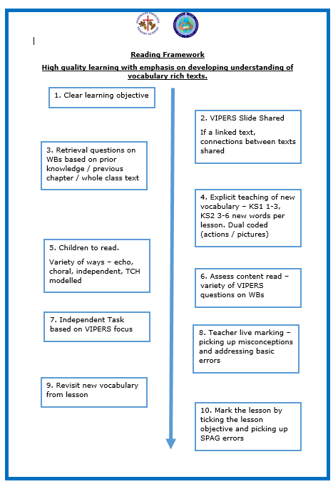
A love of reading is cultivated through initiatives such as our Bookworm reading scheme, where reading milestones are celebrated with rewards, with the aim of embedding the importance of reading from the moment children join our school community. As well as inviting classroom reading corners, and a well-stocked library, teachers will regularly share book recommendations with children in their class. To nurture a passion for reading, daily story time features engaging picture books, and children have access to a cosy, inviting book corner filled with high-quality texts.
Enrichment activities such as author visits, and links with local libraries inspire children to explore new texts and broaden their literary interests. Regular opportunities for children to review and recommend books to their peers further foster a reading community within the school.
Children working towards the expected standard in reading, are supported through a range of different pathways, from SEND support to reduce barriers to reading, to phonics assessments, and phonics interventions from KS1 – KS2 (through ELS progress), and as a school we prioritise listening to children read regularly; ensuring children regularly get the opportunity to read to an adult. We regularly assess reading at Hardwicke, to ensure that we know how to further support our children to be the best that they can be.
Within our daily phonics and guided reading lessons, children at Hardwicke receive a consistent and progressive approach to learning, and our tailored lesson design ensures every child receives quality first teaching.
- Monday to Wednesday, each class will study a carefully selected class text, and will delve into characters, themes and plots. These sessions are rich in vocabulary and opportunities for high quality discussions.
- On a Thursday, we study an unseen text; this may link to a theme in the class text, or a topic across the curriculum. These unseen texts allow for regular monitoring of progress, and ensure that children at Hardwicke are experiencing a range of fiction, non-fiction and poetry texts from YR1 to YR6.
- Fluency Friday reading sessions provide children with the opportunity to develop their reading fluency through regular practice. These sessions focus on improving accuracy, pace, and expression, helping pupils to become more confident and expressive readers. By dedicating time each week to fluency, children build essential skills that enhance their overall comprehension and enjoyment of reading, supporting their progress across all areas of learning.
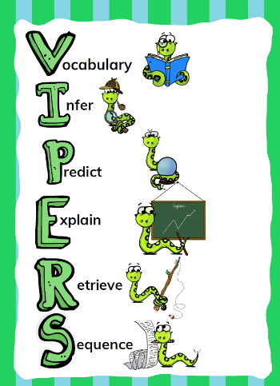
VIPERS:
At Hardwicke Parochial Academy, the VIPERS reading strands provide a structured framework to support guided reading lessons, ensuring a balanced and thorough approach to developing key reading skills. By focusing on Vocabulary, Inference, Prediction, Explanation, Retrieval, and Sequencing (or Summarising), VIPERS helps teachers design targeted questions and activities that challenge pupils at all levels. This systematic approach encourages deeper comprehension and engagement with texts, fostering critical thinking and discussion. By embedding VIPERS into guided reading sessions, the academy equips pupils with the tools needed to analyse and understand texts effectively, supporting their progress across the curriculum.

Impact: Monitoring and Evaluation:
The school tracks progress through phonics screening results, fluency benchmarks, and comprehension assessments, ensuring a clear picture of each child’s development. Pupil feedback is regularly gathered through surveys to understand their attitudes towards reading and to celebrate their growing enthusiasm. Passionate staff foster a love of reading through inclusive and engaging lessons, creating an environment where children feel inspired and supported.
Our approach prioritises progress for all, aiming for every child to achieve their potential and for our reading ARE (Age-Related Expectations) percentages to be in line with national averages. Teachers engage in regular training to refine their skills in guided reading and strategies for promoting reading for pleasure. Families play an integral role through workshops, newsletters, and reading logs, strengthening the partnership that underpins children’s success.
This cohesive approach ensures all children, from EYFS to KS2, become confident, fluent readers with a lifelong love of books. Furthermore, their reading skills provide a strong foundation for the next steps in learning, supporting academic success throughout their primary education and beyond.

  Early Reading:  The Early Years environment is filled with books for children to freely explore and enjoy. A wide range of reading materials is available, tailored to each child’s current phonics level. Activities provide a balanced approach, combining systematic phonics with storytelling, singing, and rhyming to build phonological awareness. Every day, children experience reading through modelling. |   Phonics:  Provision remains consistent through Phases 1 and 2, and extends to Phase 3 for children who need additional support. Each lesson features high-quality teaching to help children quickly develop the skills for fluent, independent reading. Phonics instruction begins on the first day in Reception, following a "keep-up, not catch-up" approach. Our goal is for all children to become confident readers as soon as possible. |   Speaking and Listening:    Reading is approached in multiple ways. In whole-class reading sessions, a variety of reading styles and strategies are used to encourage reading aloud and active listening. Every learning session includes class discussions about texts, promoting language development, vocabulary growth, and reading comprehension. | Reading Fluency:    Fluent reading serves as the bridge between decoding and comprehension. From the earliest stages, children re-read books to practice and strengthen their fluency. Additionally, we have introduced a weekly whole-class reading session focused on refining this essential skill.
  High Quality Texts:  Our reading curriculum includes a rich variety of high-quality texts, chosen to introduce children to worlds beyond their own—both real and imagined. These texts are ambitious in language and theme, offering a balanced mix of fiction, non-fiction, and poetry. Our choice of texts also link strongly to our school values. | 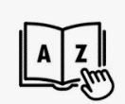  Vocabulary:  Vocabulary is a key focus during every reading lesson here at Hardwicke. We ensure we explicitly clarify new and ambitious vocabulary and many of our selected objectives are rooted in analysing the impact and effect of vocabulary used by authors in developing characters, plotlines and mood. | Reading Responses:  Our study programs consistently incorporate VIPERS comprehension questions and various written activities to help pupils achieve their learning objectives. Whole-class sessions encourage open discussions, where all views and opinions are valued, supporting our inclusive learning culture. |   Reading Culture:  At Hardwicke, reading is encouraged across all areas of learning. Every class enjoys a dedicated daily story-time where books or stories are read aloud. In the younger years, children bring in special books to share with the class. Each class takes ownership of its book corner, knowing how to access a variety of texts and genres within them.

Our Book Spine:
Our book spine has carefully been created by our teaching staff, to support our children develop a love of reading. Our key school values have been carefully considered when selecting our books, as well as ensuring a range of genres, cultures and themes run throughout the spine.
Reception | Year 1 | Year 2 | Year 3 | Year 4 | Year 5 | Year 6
We’re Going on a Bear Hunt  Elmer | The Grufallo  Julia Donaldson  The Lion Inside  Julia Bright | Saint George and the Dragon by Louie Stowell | The Adventures of Huckleberry Finn | A Long Walk to Water by Linda Sue Park | Private Peaceful by Michael Morpurgo | A Boy Called Hope by Lara Williamson
After the Storm  The Hedgehog’s Balloon  Stick Man | The Snail and the Whale  Julia Donaldson  Repunzal | The Nutcracker by Emma Helbrough | Farm Boy | Letters from The Lighthouse by Emma Carroll | Wonder by R. J. Palacio  (Lots of the values!) | High Rise Mystery  by Sharna Jackson
Jack and the Beanstalk  Jody’s Beans  Frog in Love | Percy and the Park Keeper  The Three Little Pigs | The Wind in the Willows by Kenneth Grahame | The Iron Man | The Firework Maker’s Daughter by Philip Pullman | The Nowhere Emporium by Ross MacKenzie | The Missing by Micheal Rosen
The Very Hungry Caterpillar  The Superworm | Where the Wild things are  Peace at Last | The Secret Garden  by Frances Hodgson Burnett | Charlotte’s Web | The boy at the Back of the Class by Onjali Q. Raúf | Oranges in No Man’s Land by Elizabeth Laird | The Silver Sword by Ian Serraillier
Handa’s Surprise  Rumble in the Jungle | Gorilla  Cinderella | It was a Dark and Stormy Night by Janet and Allan Ahlberg | The Lion the witch and the wardrobe. | When the Mountains Roared by Jess Butterworth | Clockwork by Philip Pullman | Welcome to Nowhere by Elizabeth Laird
Katie and the Dinosaurs  T-Rex on Tour | The Tiger who came for tea | The Railway Children  By Enid Nesbit | Nims Island | Wolf Brother by Michelle Paver | Where the Mountain Meets the Moon by Grace Lin | Wolf Wilder by Katherine Rundall

Our School Values:
Friendship | Courage | Service
Forgiveness | Perseverance | Respect

