


Special Educational Needs Information Report

Our vision is to enable all to flourish.

Status and review cycle: Statutory
Responsible group: Hardwicke Parochial Primary Academy
Next Review Date: September 2026

SEN information report
This report is the result of consultation with staff, parents of children with Special Educational Needs (SEN) and governors of Hardwicke Parochial Primary Academy and will be published annually on the School's website. The report will be updated annually to reflect the changes and plans within the school
The type of SEN provision
The Special Educational Needs and Disability (SEND) Code of Practice: for 0 – 25 years (2014) states that:
A child or young person has Special Educational Needs (SEN) if they have a learning difficulty or disability which calls for special educational provision to be made for them. A child of compulsory school age or a young person has a learning difficulty or disability if they:
- have a significantly greater difficulty in learning than the majority of others of the same age;
or b) have a disability which prevents or hinders them from making use of educational facilities of a kind generally provided for others of the same age in mainstream schools

At Hardwicke, we pride ourselves in being inclusive and will try to support every child regardless of their level of need. By encouraging independence at all age and ability levels we endeavour to develop confidence, improve self-esteem and promote enthusiasm in all our pupils. Inclusive education means supporting all pupils to learn, contribute and participate in all aspects of school life alongside their peers.
All pupils follow the National Curriculum at a level and pace that is appropriate
to their abilities. Our curriculum includes, not only the formal requirements of the Early Years Foundation Stage Curriculum / National Curriculum, but also a range of additional opportunities to enrich the experiences of all pupils.

We ensure that the Hardwicke Special Educational Needs and Disabilities
policy works within the guidelines and inclusion policies of the Code of
Practice (2014), the Local Education Authority, Equality Act 2010 and other relevant policies and legislation. In compliance with the Code of Practice 2014, we plan and provide for children with SEND within the four broad areas outlined below:
Communication and interaction
Cognition and learning
Social, emotional and mental health difficulties
Sensory and/or physical needs
  - The school's Accessibility Plan can be found here: http://www.hardwicke.gloucs.sch.uk/web/policies/501674
2 The school's policies
2.1. The school's policy for identifying and assessing people with SEN is:
The school aims to identify children with SEND as soon as possible after they arrive at the school, whether starting in Reception or moving from another school.
At Hardwicke Parochial Primary Academy, we assess each pupil’s current skills and levels of attainment on entry. Children within the Early Years Foundation Stage are identified, using the outcomes of developmental assessments as outlined in the Early Years Foundation Stage (EYFS) to target early help to children experiencing developmental delay. The identification of SEN is built into the overall approach to monitoring the progress and development of all pupils. Class and subject teachers, supported by the senior leadership team, make regular assessments of progress for all pupils. Where pupils are falling behind or making inadequate progress given their age and starting point they will be given extra support.
Adequate progress can include progress which:
• is similar to that of peers starting from the same baseline;
• matches or betters the child’s previous rate of progress;
• closes the attainment gap between the child and their peers;
• prevents the attainment gap growing wider.
Where pupils continue to make inadequate progress, despite high-quality teaching targeted at their areas of weakness, the class teacher, working with the SENCO, will assess whether the child has a significant learning difficulty. Where this is the case, then there should be agreement about the additional support that is required to support the child.

The school SENDCO is Mrs Jen Panton and is contactable on 01452 720538 or sendco@hardwicke.dgat.org.uk

2.2. The school's approach to evaluating the effectiveness of the provision for pupils with SEN:
All of our teachers view themselves as teachers of pupils with special educational needs, teaching such pupils is a whole school responsibility.
All children identified as having special educational needs have a short term plan (called a MyPlan or MyPlan+). These specify short term targets that have been set for the child and details of the provision that will be put in place to help them to meet them. The SENDCO monitors all MyPlans and MyPlan+ and the provision that is provided. These plans are reviewed termly and targets and provision are assessed.

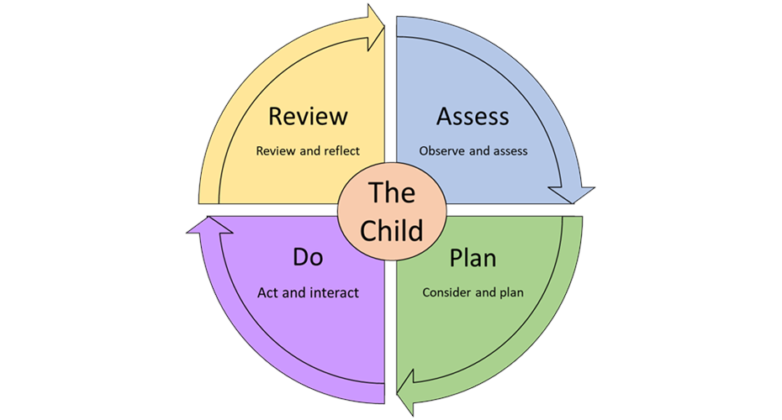
2.3. The arrangements for assessing and reviewing the progress of children and young people with SEN:

3 School's approach to teaching
The school's approach to teaching pupils with SEN (including pupils who do and do not have an EHCP plan)
3.1 by adapting the curriculum, equipment and learning environment is varied and personalised. Adaptions might include:
- Fluid groupings
- 1:1 support and small group support.
- Pre-teaching of vocabulary
- Giving longer processing time
- Providing scaffolding and adapting tasks
- Quiet workstation
- Providing multi-sensory aids and concrete apparatus
- Breaking down instructions
- Social stories
- Movement and sensory breaks.
- Bespoke curricula
- Using alternative methods to record children’s ideas – eg laptops, text to type software on iPads
3.2 with additional support for learning is:
- Adapting staffing and moving staff to areas with the most need
- Reinforcing and retrieval practice in small groups or 1:1
- Daily precision teaching and over learning of key facts

3.3 through activities available to pupils with SEND in addition to those available through the curriculum is
- Attendance at after school clubs, often with a wide range of clubs to include all interests and abilities.
- Use of quieter spaces around the school
- Sharing information and resources with after-school club
- Inclusive sports activities organised by Atlas to enable all children to represent the school
- Ensuring that all whole school events, eg sports days and theme days, are fully inclusive

3.4 through improving the emotional, mental and social development of pupils with SEN is:
- Welcoming each child into school each day, ensuring our children know that they belong and that they are missed if they are not here
- Our school vision is “Do everything in love”. We aim to have a supportive, inclusive and accepting environment in which all children feel valued and loved.
- Ensuring all children have trusted adults in school to whom they can go if they need to talk
- SENDCo is available every lunchtime in school for children to chat to if they are feeling upset
- Lunch club available for those children for whom the school dinner hall is too overwhelming
- Working with and making referrals to outside agencies such as Early Help, Barnardos, Tic+, school nursing team
4 The School's facilities
4.1 The school's facilities to include pupils with SEN and how new or specialist equipment and facilities is obtained:
- Wheelchair accessible, single storey building
- Accessible toilets
- Other adaptions can be made where necessary in consultation with LEA Occupational Health team.
5 The School's training
5.1 The school's arrangements for training staff in relation to pupils with SEN is:
- Training needs are identified and training provided to meet the needs of our pupils.
- Staff meetings are used to provide CPD to our teachers and TAs, including use of adaption as a vital element of Quality First Teaching.
- Acting on advice of outside professionals, such as Educational Psychologists, the Advisory Teaching Service and Speech Therapists, we source training for our staff who disseminate information throughout the school.
5.2 Specialist expertise is obtained by the school by
Attending courses and training where available. Recent training for staff has included 5 teaching assistants taking part in speech therapy training, a pastoral TA doing Lego Therapy training, the EYFS lead completing a training course for Total Communication.
6 The School's consultation
The school's arrangements to consult with and involve:
6.1. parents of pupils with SEN about the education of their child is:
• Dojo messages sent by SENDCO and class teachers
• SENDCO has open door policy. Conversations can happen on playground before school, or privately after morning drop off.
• MyPlans will be reviewed and parents will be invited in to approve and sign them at parents’ evening.
• Parents will be invited in for MyPlan+ and EHCP reviews.
• Parents evening sessions available to see class teacher and SENDCO
• An annual report will be issued at the end of the academic year.
6.2. pupils about their education is:
• Class teachers and teaching assistants will give feedback in the moment. The SENDCO conducts termly pupil voice sessions in order to ensure that children are happy with the support that they are receiving.
7 The School's Partnerships
7.1. The school's governing board / proprietor involves other bodies (including health and social care bodies, local authority support services, and voluntary sector organisations) to meet the needs of pupils with SEN and their families by:
• Liaising with Local Authority support services, such as the Advisory Teaching Service, Educational Psychology Service, Educational Inclusion Service, Team Around the Locality Cluster, Early Help and Social Services in order to gain extra help and support for children and families.
• The school works with voluntary agencies such as Barnardos and Tic+ in order to support our children and families to receive extra support.
• The SENDCo works closely with health professionals, such as speech and language therapists and occupational therapists and ensures that their advice is actioned in the classroom. The SENDCo also sends to referrals to SCAAS (the Communication and Autism team) and to paediatric services if necessary.
7.2. The school's arrangements for supporting pupils who are looked after by the local authority and have SEN:
• The SENDCO liaises with the Virtual School, child and carers and attends termly PEP meetings. The SENDCO ensures that provision for the targets outlined in the PEP are in place.
7.3. The school's arrangements of pupils with SEN transferring between other education providers is
• SENDCO meets with child and parents before they begin attending Hardwicke in order to ascertain need and ensure that a successful transition is made. Extra visits to the child’s new learning environment are made.
• Parents of children with SEN moving on from Hardwicke to secondary settings are offered meeting with SENCOs and learning support assistants from both schools in order to pass on key information. Children will have enhanced transition session, with extra supported visits to their new school.
7.4. The school collaborates between the following education providers and other settings:
• Preschool, nurseries and childminders
• Secondary schools : Severn Vale, Maidenhill, Archway, Ribston Hall, SHS,
• Specialist schools : Sladewood Academy, Shubberies, The Ridge, Brookthorpe Hall, Alderman Knight.
• Alternative settings: Wickselm House, First Thought, All Things SEN.

8 The School's key contacts
SEN co-ordinator: Jen Panton. sendco@hardwicke.dgat.org.uk
The contact for complaints from parents with pupils with SEN: head@hardwicke.dgat.org.uk
The school's complaints policy can be found here: http://www.hardwicke.gloucs.sch.uk/web/policies/501674

9 The School's Link to the Gloucestershire Local Offer
Information for the Local Offer for Gloucestershire and the school's contribution to the Local Offer is available at https://www.glosfamiliesdirectory.org.uk/kb5/gloucs/glosfamilies/family.page?familychannel=2_1
The Gloucestershire Local Offer provides information and advice on Special Education Needs and Disabilities and their families. If you wish to contact the Gloucestershire County Council about the Local Offer please call Special Educational Needs and Disability Information Advice and Support Service (SENDIASS) on Freephone: 0800 158 3603 or Direct Line: 01452 389344/5.

Next review date : September 2026

Signed
Senco - Mrs Jennifer Panton
Headteacher- Miss Sharon Cale

