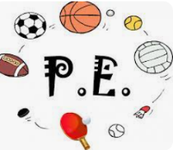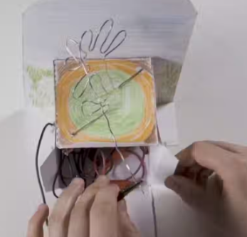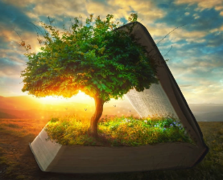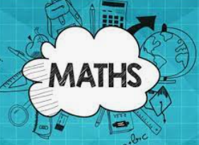 s

**Computing:**

**Designing our own webpage**

* Use search technologies effectively, appreciate how results are selected and ranked, and be discerning in evaluating digital content
* Select, use, and combine a variety of software (including internet services) on a range of digital devices to design and create a range of programs, systems, and content that accomplish given goals, including collecting, analysing, evaluating, and presenting data and information.
* use technology safely, respectfully, and responsibly; recognise acceptable/unacceptable behaviour.

**Science**:

This unit ‘Animals, including humans’ takes children through six lessons where they learn how to: identify and name the main parts of the human circulatory system, and describe the functions of the heart, blood vessels and blood; recognise the impact of diet, exercise, drugs and lifestyle on the way their bodies function; and finally, they learn how to describe the ways in which nutrients and water are transported within animals, including humans.

**History of WW2:**

* Understand where WWII sits in the timeline of world history
* Understand where WWII sits in the timeline of our recent history
* Understand why and how Hitler rose to power
* Understand and recognise differing styles of leadership
* Understand ‘The Blitz’ and how it impacted the life of those in Britain
* Understand the life of a child holocaust survivor in WW2
* Consider the reliability of sources and understand if everyone affected by WW2 in the same way

**English**: This term we will be focusing on non-fiction texts. We will look at biographies, as a text type, and then research and write our own, based upon Marcus Rashford, Michelle Obama and Anne Frank.

Then, we will focus on recount texts, and write our own newspaper reports based on Hardwicke during WW2, and Christmas on No-Man’s Land.

Before Christmas, we will use the ‘Little Match girl’ as a narrative stimulus.

**Music**:

**Pop Art**

Theme and variations is a common musical structure, especially in classical music. The structure features a theme at the start of the piece, then once the theme has been played, the composer repeats it but with some form of variation. The theme is then played again but this time with a further variation.

**Guided Reading:**

6F – Machine Gunners – Robert Westall

6C – The Missing – Michael Rosen

Using our “ERIC” skills, we will be looking at how writers create different effects and moods and will be inferring the meaning of texts. Vocabulary will be a major focus, with lots of dictionary work.

PE WILL BE ON A FRIDAY!



**Religious Education:**

* What does Genesis mean?
* What type of text is Genesis?
* What is cosmology and evolution?
* How can Genesis answer question about the beginning of life and the universe?
* How can science and faith go together?
* Creation and Science: Is it conflicting or complementary?

In maths we will be focusing on extending our knowledge of fractions, decimals and percentages, as well as looking at geometry of shapes.

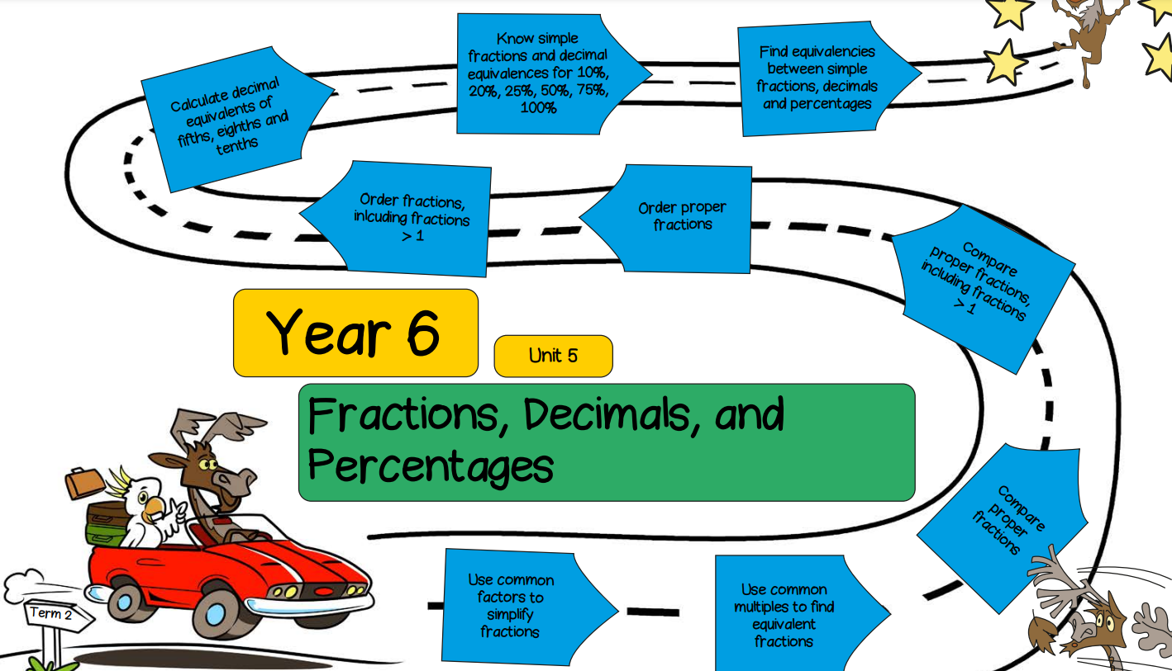

**French**: French Football Champions!

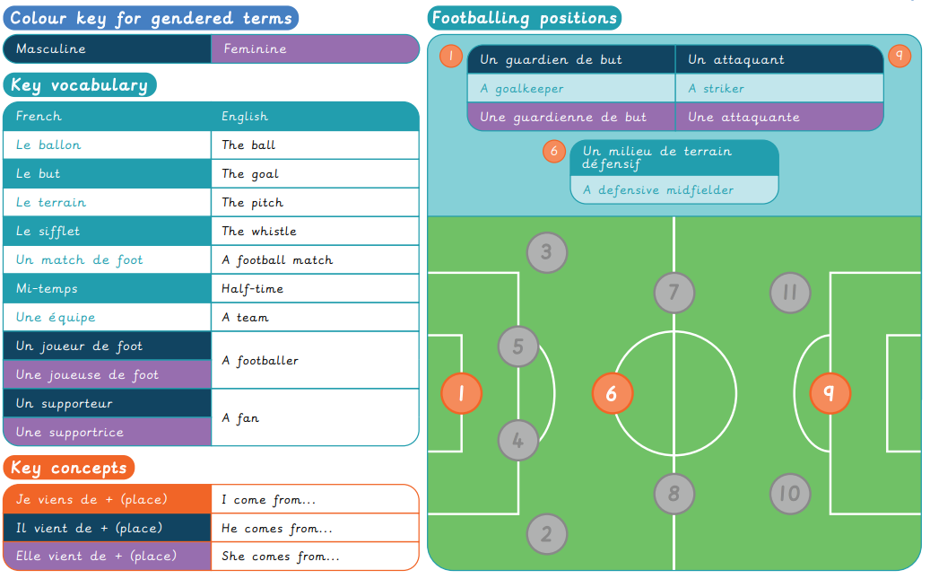

**Y6- Autumn 2**

**PSHCE**:

**Valuing Differences**

The characteristics of friendships, including mutual respect, truthfulness, trustworthiness, loyalty, kindness, generosity, trust, sharing interests and experiences and support with problems and difficulties.

The importance of respecting others, even when they are very different from them (for example, physically, in character, personality or backgrounds), or make different choices or have different preferences or beliefs

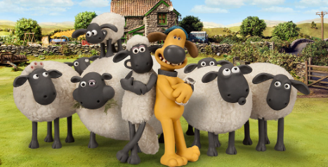

**DT –**

The children will be linking the science knowledge of circuits, to design a steady hand game.