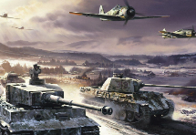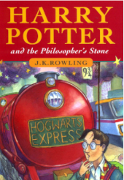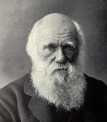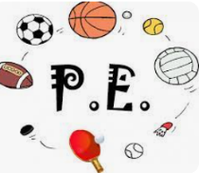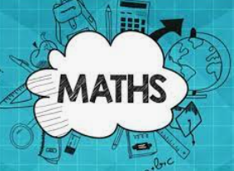 s

**Science**:

**Evolution and Inheritance**

•Identical and non-identical off-spring

•Fossil evidence and evolution

•Adaptation and evolution

**Guided Reading:**

6C – Machine Gunners – Robert Westall

6F – The Missing – Michael Rosen

Using our “ERIC” skills, we will be looking at how writers create different effects and moods and will be inferring the meaning of texts. Vocabulary will be a major focus, with lots of dictionary work.

PE WILL BE ON A Tuesday

Rugby!

Functional movement focusing on leg muscles

Technique of rugby pass and catching a rugby ball in pairs

Using tag belts

Using competition to develop our skills, and team work!



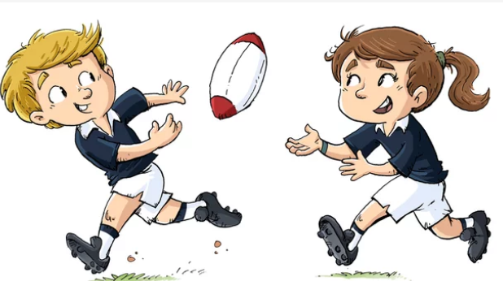

**Music**: 

Songs of WW2.

We will compare songs from WW1 and WW2, focusing then on ‘The White Cliffs of Dover’, where we will sing the melody, and counter melody, ready for our trip!

**English**: This term will be focusing on our Fiction writing. We will be looking at narratives using Harry Potter and The Philosopher’s Stone as our guide!

Sentence level work will include learning about exclamation marks, prepositions, conjunctions and adding dialogue to the narrative. The children will be encouraged to edit and improve their work independently. We will begin looking at YR6 SPAG focuses.

**Computing:**

* To describe how computing networks physically connect to other networks (communicate)
* To recognise how networked devices make up the internet
* To outline how websites can be shared via the World Wide Web (WWW)
* To describe how content can be added and accessed on the World Wide Web (WWW)
* To recognise how the content of the WWW is created by people

To evaluate the consequences of unreliable content



**History of WW2:**

* Understand where WWII sits in the timeline of world history
* Understand where WWII sits in the timeline of our recent history
* Understand why and how Hitler rose to power
* Understand and recognise differing styles of leadership
* Understand ‘The Blitz’ and how it impacted the life of those in Britain
* Understand the life of a child holocaust survivor in WW2
* Consider the reliability of sources and understand if everyone affected by WW2 in the same way

**Religious Education:**

Why do Hindus want to be good?

We will be looking at Hindu beliefs, and the ideas and concepts that encourage them to be ‘good’. We will recap the Trimurti, and compare Hinduism beliefs to those in Christianity.

In maths we will be revisiting place value and learning to read and write and order numbers up to 7-digits. Rounding to 10s, 100s and 1000s will be another objective.

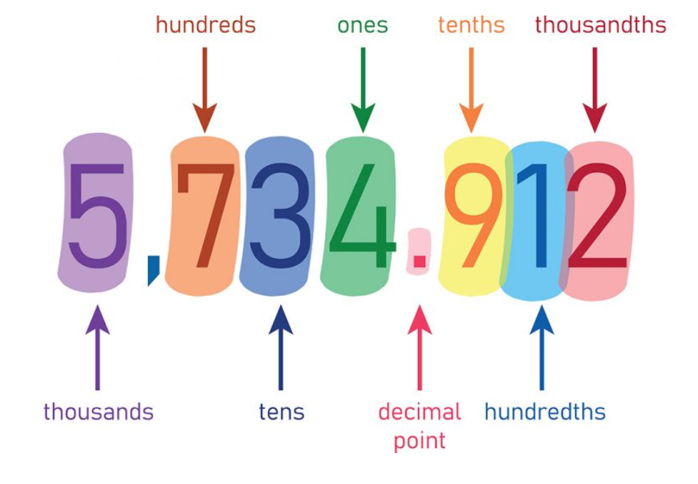

**French**: French Sports and the Olympics!

Names of sports, masculine and feminine verbs, being able to talk about likes and dislikes.



**Y6- Autumn 1**

**PSHCE**:

**Me and my relationships**

Demonstrate strategies for working on a collaborative task;

Define successful qualities of teamwork and collaboration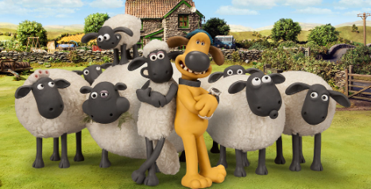

**Art:** This term we will be developing sketching techniques – including mark making, investigating shape/form and perspective and composition.

