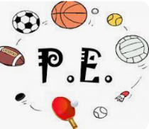
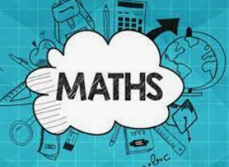

s
Religious Education:
HINDUISM
Identify some Hindu deities and say how they help Hindus describe God
• Make clear links between some stories (e.g. Svetaketu, Ganesh,
Diwali) and what Hindus believe about God
• Offer informed suggestions about what Hindu murtis express
about God
• Make simple links between beliefs about God and how Hindus live
(e.g. choosing a deity and worshipping at a Home Shrine;
celebrating Diwali)

Geography:
Know where the main mountain regions are in the UK
Know, name and locate the main rivers in the UK
Know and label the main features of a river (cross ref. science re Water Cycle)
Know how to plan a journey within the UK, using a road map
Science: States of Matter – solids, liquids and gases

French: Getting Dressed – clothes and descriptions
Listening and responding to full sentences.
Listening and noticing rhyming words when joining in with songs.
Beginning to notice common spelling patterns.

Guided Reading:
4P – Roald Dahl – Danny the Champion of the World
4W – Phillip Pulman – The Firework Maker’s Daughter
Using our “ERIC” skills, we will be looking at how writers create different effects and moods and will be inferring the meaning of texts. Vocabulary will be a major focus, with lots of dictionary work.

English: This term will be focusing on non-fiction and reports/recounts. As a focus, we will study the events in the life of the inspirational Pakistani girl, Malala Yousafzai.

The children will study how different types of texts need to look and be constructed. They will continue to focus on editing and improving their own work.

Music: 
ROCK & ROLL! Learning about the origin and features of rock and roll music, pupils learn how to play the Hand Jive and Rock Around the Clock, looking specifically at a walking bass line, before performing a piece as a class.

PSHCE:
Valuing Differences: we will be able to:
- Define the terms 'negotiation' and 'compromise';
- Understand the need to manage conflict or differences
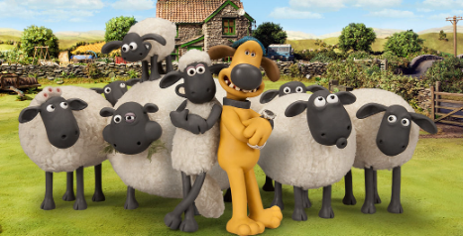

Computing:
- To identify that sound can be digitally recorded
- To use a digital device to record sound
- To explain that a digital recording is stored as a file
- To explain that audio can be changed through editing
- To show that different types of audio can be combined and played together


PE WILL BE ON A FRIDAY.
Netball/Basketball
Chest and Bounce pass technique - add movement
Invasion Games:
Basketball:
Steal (tackling) in basketball – build up from 1 v 1 scenarios in channels
Passing in small teams (6) on the move combined with bouncing



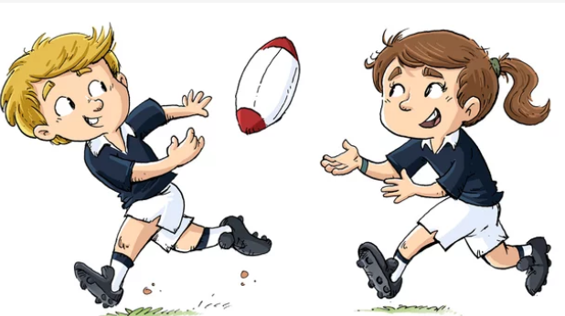

In maths we will be adding, subtracting and multiplying four digit numbers. We will continue to practise Times Tables in readiness for the Y4 MTC.
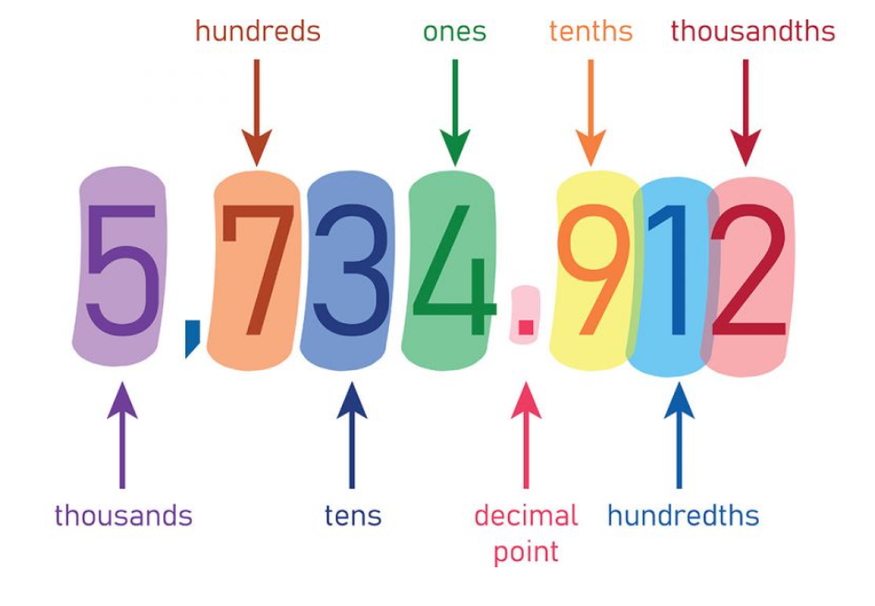

Y4- Autumn 2
DT:
This term we will be designing and making Pavilions, using a variety of hand tools and adhesives.


